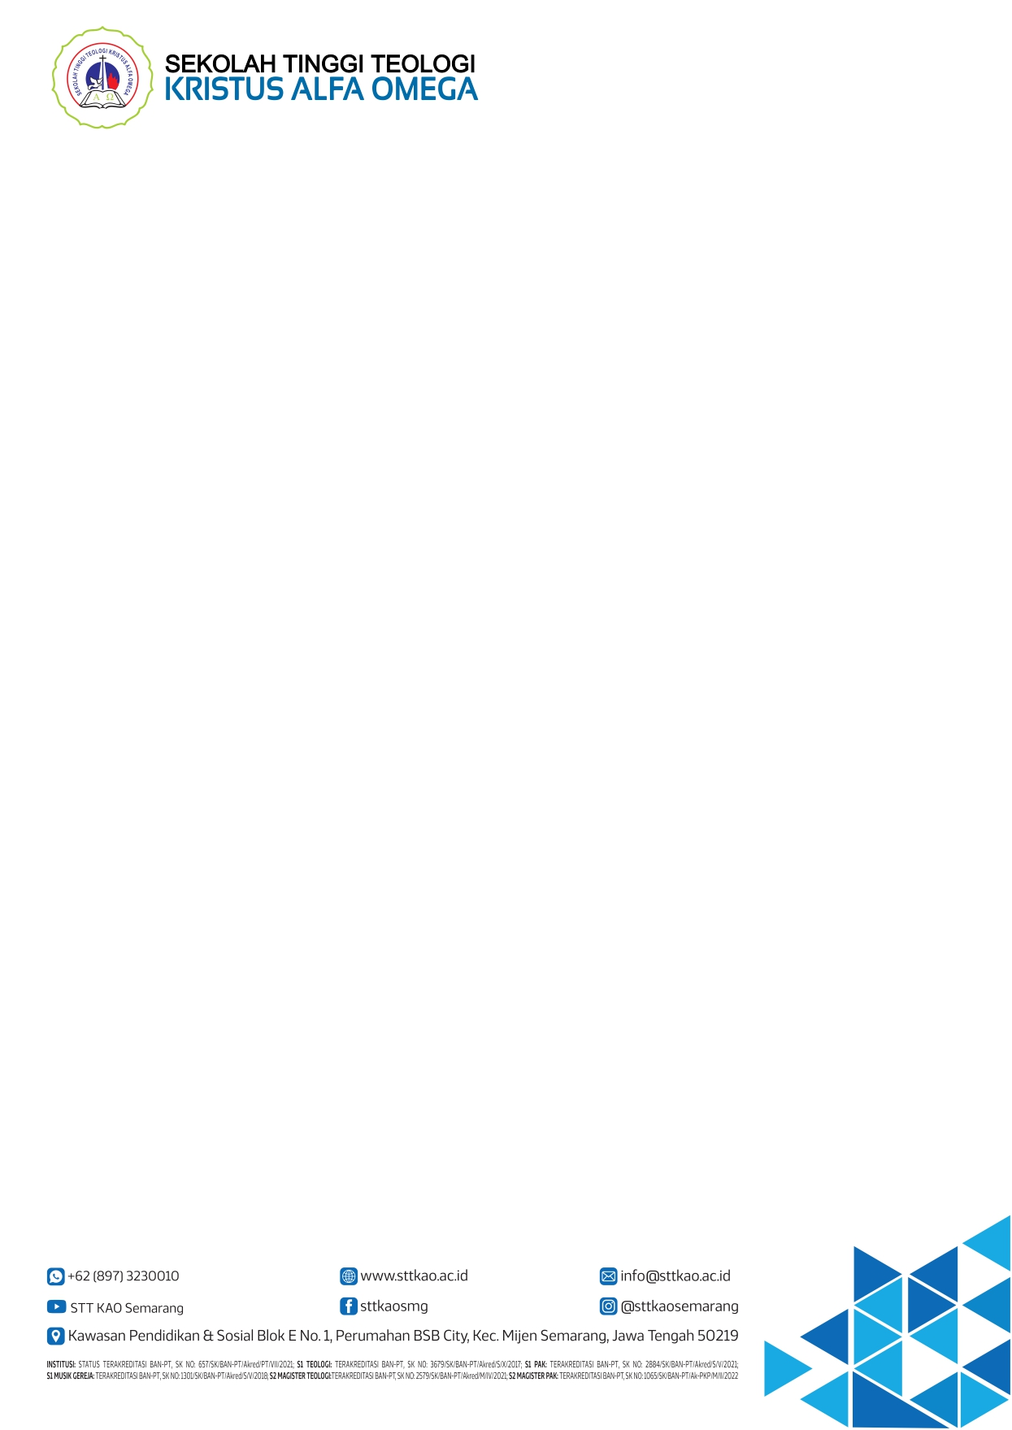
KURIKULUM PROGRAM STUDI MAGISTER TEOLOGI
SEKOLAH TINGGI TEOLOGI KRISTUS ALFA OMEGA

NO. | MATA KULIAH | KODE MK | SKS
A. | KURIKULUM INTI (25 SKS)
 | Hebrew Advance | MTH0101 | 3
 | Greek Advance | MTH0102 | 3
 | Old Testament Exegesis | MTH0103 | 3
 | New Testament Exegesis | MTH0104 | 3
 | Old Testament Culture of Biblical Israel Advance | MTH0105 | 2
 | Research Methodology | MTH0106 | 3
 | Tesis | MTH0107 | 8
B. | KURIKULUM INSTITUSIONAL (9 SKS)
 | Sistematic Teologi Advance | MTH0208 | 3
 | Tranformational Leadership | MTH0209 | 2
 | Pentacostal Theology | MTH0210 | 2
 | Tabernacle Theology | MTH0211 | 2
C. | KURIKULUM KONSENTERASI (12 SKS)
 | Konsenterasi Teologi
 | Pastoral Counseling | MTH0312 | 3
 | Modern Digital Evangelism | MTH0313 | 2
 | Compassion Ministry | MTH0314 | 3
 | English For Theology | MTH0315 | 2
 | Management of Christian Organization | MTH0316 | 2
D. | KURIKULUM MATRIKULASI (10 SKS)
 | Hermeneutic | MTH0317 | 2
 | Introduction Old Testament & New Testament | MTH0318 | 2
19. | Hebrew Basic | MTH0319 | 2
20. | Greek Basic | MTH0320 | 2
21. | Introduction Sistematic | MTH0321 | 2
SKS Latar Belakang S1 Teologi |  |  | 46
SKS Latar Belakang S1 Non-Teologi |  |  | 56

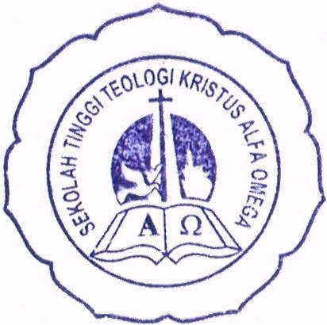
STT Kristus Alfa Omega Semarang, 03 Maret 2023
Ketua Direktur Pascasarjana



Dr. Dipl.-Ing. Gregorius Suwito, M.Th. Dr. Tantri Yulia, M.Th.,M,Pd.
NIDN: 2302127401 NIDN: 2317067201

